Author Formatting Guide and Template
This document provides a formatting template and quick-reference guide for preparing manuscripts for submission to the Online Learning Journal (OLJ).
Authors may use this template by replacing the sample text, tables, and figures. Delete all instructional text (bracketed guidance) before submission.
For detailed guidance on manuscript content and expectations, refer to the Author Guidebook and Submission Checklist.
💡 Note: This document focuses on formatting. All policy, ethical, and submission requirements are outlined in the Author Guidebook and must be followed prior to submission.
⚠️ Important: Blind your manuscript for peer review. Do not include author names or affiliations in the submitted document. Submit author information separately.
Page Setup
- Margins: 1” on all sides
- Paper Size: 8.5” × 11” (portrait)
- Alignment: Left-aligned text
- Spacing: Single-spaced with one blank line between paragraphs
- Page Numbers: Do not include
- Headers/Footers: Do not include (added during production)

💡 Note: OLJ uses a modified APA style. Follow these specifications rather than default Word or APA settings where differences occur.

Paper Style
- Font: Times New Roman, 12 pt (except where specified)
- Use APA 7th edition for citations and references
- Use the Oxford comma
- Use a single space between sentences

In-Text Citations and References
- Follow APA 7th edition guidelines
- Use hanging indents for references
- Include DOIs (https://doi.org/...) for all sources where available
- Include stable URLs when DOIs are not available
- Footnotes are not allowed due to the journal’s online formatting. Incorporate notes as numbered references instead.

⚠️ Important: References must be accurate and verifiable. Incomplete or incorrect references may delay review or result in rejection.

Tables and Figures
- Number tables and figures sequentially (Table 1, Figure 1, etc.)
- Place titles above tables/figures
- Use bold for table/figure numbers (e.g., Table 1)
- Use italicized titles in title case
- Include notes below tables/figures in 10 pt font

💡 For accessibility and design requirements (e.g., alt text, contrast), see the Guidance for Accessible Figures section in the Author Guidebook.

Heading Levels
- All headings should be in Title Case
- These heading styles differ slightly from standard APA formatting and should be followed for OLJ submissions.

Title (20 pt. New Roman, Centered, Bold)

Heading 1 (16 pt. Times New Roman, Centered, Bold)

Heading 2 (12 pt. Times New Roman, Left Aligned, Italics, Bold)

Heading 3 (12 pt. Times New Roman, Left aligned, Underlined)

Title of Paper: Clear and Descriptive

Author Name [12pt, Times New Roman, Centered]
Author Affiliation [12pt, Times New Roman, Centered, Italics]

One author, no affiliation
Artie S. Author, PhD
Rochester, New York
Two authors (with suffices), one affiliation
John Q. Public II and Roy G. Biv Jr.
Educational Product Service, Princeton, New Jersey
Two authors, two affiliations
Sally Scholar
University of California, Berkley
Richard Researcher
Brandon University
Three authors, two affiliations
Meredith Manuscript and Mix D. Methods
Georgetown University
Qual I. Tative
Dartmouth College

Abstract
[Insert abstract here (maximum 250 words). Include purpose, methods, key findings, and conclusions.]

Example (Condensed):
This study examined… using a [mixed-methods] design… Findings indicated… Results suggest…

Keywords: APA; Online learning; Templates; Format; OLJ
[Provide 3–6 keywords. Use standard terms to support indexing and discoverability.]

Introduction
[Body text. 12 pt Times New Roman, left aligned, indent, 1 space between paragraphs.] Sed varius leo eu arcu pulvinar rutrum. Vivamus faucibus euismod est, vitae lobortis nisi vehicula vitae. Curabitur hendrerit, nulla ultrices efficitur convallis, neque massa ornare nisl, vel sodales nisl eros in ex. Aenean scelerisque augue ac augue eleifend eleifend. Sed viverra, libero et aliquet volutpat, odio diam accumsan purus, a tincidunt lacus sapien consequat metus. Pellentesque lacinia quam et ligula ullamcorper dapibus. In tellus lacus, porta nec accumsan vitae, consequat vitae lorem. Ut non eleifend sem. Aenean aliquam purus sed nibh iaculis, eu sodales sapien consectetur. In turpis nulla, condimentum ac dolor pellentesque, consequat auctor neque. Integer nec quam consequat, finibus sem eu, vulputate augue. Ut ex urna, malesuada in tortor quis, elementum dignissim erat.

Paragraph 2 example text. Curabitur hendrerit, nulla ultrices efficitur convallis, neque massa ornare nisl, vel sodales nisl eros in ex.

Literature Review
Praesent dignissim, elit sit amet efficitur tincidunt, est magna elementum ligula, non finibus tellus urna quis velit. Aenean vulputate tempus elementum. Morbi quis odio pretium, sollicitudin lacus nec, blandit leo. Etiam varius nisi quis ex vehicula, id blandit lectus pellentesque. Sed accumsan eget dui ut mattis. Ut et pharetra ligula. Sed mattis lacus in mi rhoncus, id scelerisque justo consequat. In rutrum dapibus ex, et posuere nulla auctor vitae. Nunc eu accumsan sapien, eu finibus elit. Etiam vitae pharetra massa. Nullam suscipit vehicula elit accumsan tempor.

Phasellus nec lectus vel sem sollicitudin molestie at ut sapien. Maecenas convallis purus nec leo suscipit molestie. Sed quis convallis felis. Integer at pharetra velit. Vivamus porta elementum massa a feugiat. Aliquam iaculis dictum massa, eu elementum dui elementum ut. Ut ornare et orci in vehicula. Etiam ut hendrerit purus.

Literature 1
Pellentesque habitant morbi tristique senectus et netus et malesuada fames ac turpis egestas. Maecenas blandit nisl ut odio ultricies laoreet. Aenean enim tortor, accumsan nec semper et, dapibus ac purus. Praesent et lorem accumsan, sodales nulla non, posuere enim. Nulla facilisi. Aliquam rutrum, dui et mattis viverra, velit sem dignissim leo, et eleifend purus risus tristique turpis. Nam blandit vitae enim et porta.

Literature 1 Analysis: An Analysis of Literature.
Pellentesque venenatis consequat massa, in dapibus arcu consectetur ac. Vestibulum mollis leo ut leo scelerisque imperdiet. Vestibulum volutpat, purus ut tempus fringilla, elit lacus pellentesque tortor, sed sodales diam mauris eget leo. In sagittis diam vel ipsum luctus, a vestibulum orci convallis. Suspendisse id eros urna. Nullam non porttitor tortor, sed mollis massa.
Donec sit amet tincidunt velit, ut commodo metus. Aliquam ornare eleifend ullamcorper. Sed a bibendum purus. Morbi sollicitudin imperdiet porttitor. Aenean in sem magna. Cras mollis vestibulum vestibulum. Donec pulvinar orci nec nunc venenatis, et tincidunt tellus aliquet. Sed varius eros quis pharetra volutpat. Vestibulum venenatis ex nec odio pharetra, vitae mattis dui molestie.
Maecenas id sagittis metus. Sed vel fringilla massa, et pretium augue. Nullam semper lacinia eros, non sollicitudin arcu hendrerit et. In vel lectus lectus. Donec et eleifend justo. Aliquam eu egestas orci. Suspendisse bibendum nibh dui. Integer pretium congue varius. Morbi mattis lobortis dolor non convallis. Nulla ac vehicula tortor.

Methods
Vivamus vestibulum mauris risus, non ornare purus consectetur accumsan. Aliquam luctus blandit diam a blandit. Duis rhoncus, nibh at porta bibendum, elit diam rhoncus nibh, at mollis lectus enim nec odio. Sed sit amet libero non leo efficitur aliquet. Integer vitae ex nec mi blandit interdum. Praesent commodo nisl quis magna rutrum, vel commodo mauris consectetur. Suspendisse potenti. Ut varius, ante at consectetur posuere, nibh odio malesuada nunc, at malesuada nulla tellus nec metus.

Duis sit amet venenatis eros. Aenean auctor lacus purus, eget rhoncus velit malesuada vitae. Aliquam id dolor ultrices, viverra lectus nec, dignissim massa. Aenean sit amet ultrices dui. Nulla vehicula lobortis dui, id posuere arcu ultrices sit amet. Donec quis pellentesque urna, quis dapibus lacus. Nulla facilisi.

Table 1

Table Title Here [Italicized]

Data Set 1 | Data Set 2 | Data Set 3
One | 1 | 10
Two | 3 | 20
Three | 5 | 30
Note. Place any table notes here [10pt font].

Fusce consequat, mi non semper rhoncus, turpis turpis suscipit massa, et semper nulla leo porttitor erat. Pellentesque habitant morbi tristique senectus et netus et malesuada fames ac turpis egestas. Ut luctus, nisi at varius consequat, quam ante auctor felis, non vehicula felis erat eget mi. Etiam eros lacus, pretium quis neque a, vestibulum pretium quam.

Results
Nullam quam justo, scelerisque id felis a, ullamcorper porta tellus. Maecenas pretium tincidunt erat. Mauris ultrices ipsum in ipsum mattis congue. In blandit egestas tincidunt. Vivamus facilisis mattis eleifend. Pellentesque dolor eros, dictum quis condimentum a, eleifend malesuada orci. Quisque in sagittis risus.

Figure 1

Figure Title Here [Italicized, Title Case, no period after table and figure numbering]
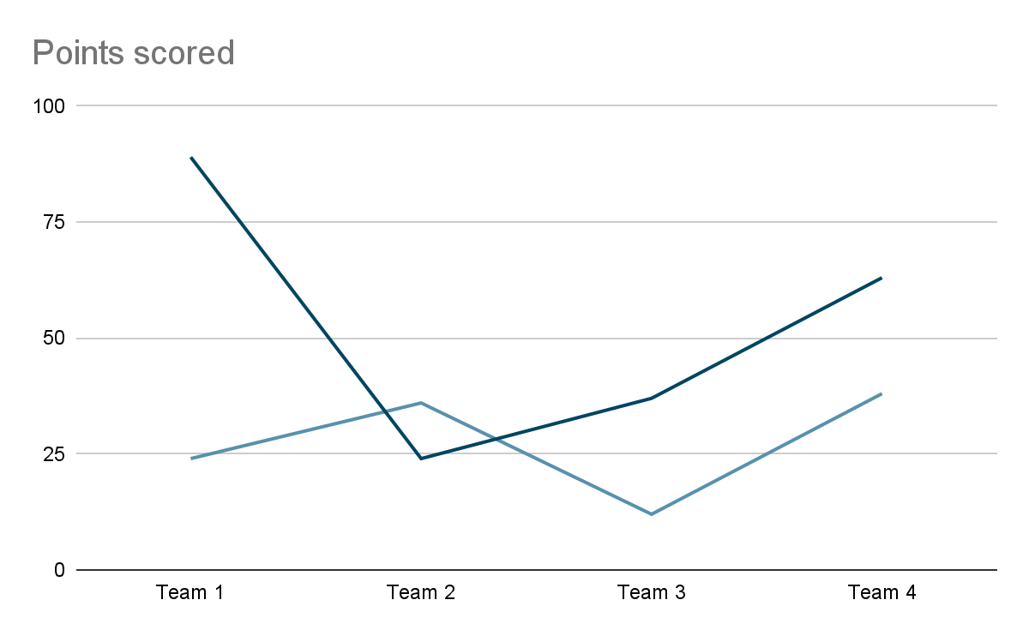
Note. Place figure notes and legends here [10 pt. font].

Mauris hendrerit dapibus molestie. Sed quis condimentum nunc. In non volutpat odio, eget laoreet mi. Vivamus tristique lacus sit amet metus ullamcorper congue. Nulla tellus dui, dapibus a eros maximus, egestas finibus elit. Vivamus sapien elit, convallis nec libero eu, facilisis feugiat felis. Ut sed felis ut nisi vestibulum accumsan.

Discussion
Duis nec nisi luctus, imperdiet dolor sit amet, lacinia tellus. Curabitur tempus felis id auctor finibus. Vestibulum lacus arcu, faucibus quis risus in, luctus tincidunt ipsum. Morbi non pulvinar lorem. In vulputate enim eu nisi tempus, sit amet semper leo ullamcorper. Ut et ipsum at lectus efficitur ullamcorper. Aliquam erat volutpat. Aliquam eleifend non diam a viverra. Curabitur metus mi, efficitur vel tortor eget, viverra placerat erat. Fusce at aliquet lorem, at auctor nibh. Praesent vel ex justo.

Conclusion
Maecenas a ex hendrerit, sollicitudin purus eget, fringilla ligula. Aenean egestas tortor nibh, nec rutrum nibh tristique eget. Phasellus rutrum libero id feugiat accumsan. Nulla maximus diam nec laoreet cursus. Duis aliquam sit amet quam nec aliquam. Fusce sollicitudin luctus est vel dictum. Fusce id convallis enim, vitae aliquet mi. Mauris tincidunt commodo blandit. Nunc sagittis lacus eget diam luctus, id egestas diam gravida. Morbi eu diam rhoncus, euismod purus quis, finibus quam. Proin rutrum sed ipsum vitae iaculis. Ut ac fringilla ipsum. Aenean ligula mauris, laoreet et orci non, iaculis auctor nunc. Ut justo ipsum, volutpat sit amet sem sit amet, semper congue velit.

Declarations
[Include the following statements after the conclusion. Adjust each section as appropriate for your study.]
⚠️ Important: All applicable statements must be included. Missing declarations may result in return or rejection prior to review.

Acknowledgments
The authors wish to thank [individuals, groups, or institutions] who contributed to this work but did not meet the criteria for authorship. In particular, we acknowledge [specific contributions, such as technical assistance, editorial feedback, access to facilities, or administrative support].
[If applicable, please also acknowledge funding agencies or programs here if not already detailed in the Funding section.]

Ethics Statement
This study was conducted in accordance with recognized ethical standards. Informed consent was obtained from all participants, and data were collected and reported with respect for confidentiality and anonymity.
[If applicable, please specify: e.g., “The study protocol was reviewed and approved by the Institutional Review Board of [University/Organization], Approval No. XXXX.”]
[If ethics approval was not required, please specify: e.g., “According to the guidelines of [University/Organization], this type of research did not require formal ethics approval.”]

Funding Statement
This research received no external funding.
[If funding was received, please specify: e.g., “This work was supported by the National Science Foundation under Grant No. XXXX.”]

AI Use Statement
Generative artificial intelligence (AI) was used in the preparation of this manuscript for [briefly describe purpose, e.g., “grammar and style refinement” or “APA 7th edition reference formatting”] using [AI tool, version]. The AI tool was not used to generate, analyze, or interpret research data, nor to create original scholarly content. All content was reviewed, verified, and approved by the authors, who take full responsibility for the accuracy and integrity of the work.

Conflicts of Interest Statement
The authors declare no conflicts of interest related to the research, authorship, or publication of this article. (If conflicts exist, please specify: e.g., “Author A has received consulting fees from Organization B, which may be perceived as influencing this research.”)

References
Author, A.A. (Year of publication). Article title in sentence case. Journal Title in italics, Volume(issue if available), pages. https://doi.org/xxx

Author, A. A., & Author, B. B. (Year of publication). Article title in sentence case. Journal Title in italics, Volume(issue if available), pages. https://doi.org/xxx

Author, A. A., Author, B. B., & Author, C. C. (Year of publication). Article title in sentence case. Journal Title in italics, Volume(issue if available), pages. https://doi.org/xxx

💡 Include DOIs for all references where available. For additional examples, see APA Style guidelines.

Appendices and Supplemental Materials
- Reference all appendices in the manuscript
- Label sequentially (Appendix A, Appendix B, etc.)
- Include only materials that directly support the study

⚠️ Do not include:
- Unreferenced material
- Excessive qualitative excerpts
- Identifiable or restricted data

